Project Milestone 2

Team: Xiomara, Tina, Henry

This is to ensure that you are making significant progress towards your project in the class. This is the second milestone with the following deliverables:

1. The final information items that you are planning to include in the final dashboard and how they would help the business.

The final dashboard will consist of historical data and trends from 358 teams/schools across 5 sports. This will offer school administrators information on the effectiveness of past investments. We hope to include financial comparison, geo mappings, and temporal graphs. Some of which include:

**Win percentages (line graph):**

* % of games won by eachs schools sports teams, over the last 10 years.
* This helps set a baseline benchmark for each school and assists in obtaining metrics to evaluate the sports program and its coaches.

**Total Expenses (line graph)**

* Visualizes the fluctuations/trends of expenses incurred by each school’s athletic programs over the years.
* Stake holders can view the spending patterns, and help identitfy the correlation between spending and win/loses.

**Geo Mapping (interactive map)**

* Using the participating school’s address (zipcode) and
* Identify regional performance patterns (what sports do better where), how spending varies between locations, and identify areas that are underperforming.

**Athletic Spending vs Operating expenses**

* Allows stakeholder to see how resources are proportional to athletic spending.

**Athletic Expense Breakdown** (Thinking: stacked bar chart for each school)

* Can be used for further cost analysis and how resources are allocared.

**School Breakdown**

* Used to compare with other schools, the variation of sports offered.

1. ERD for the star schema that would provide information for the dashboard described above.

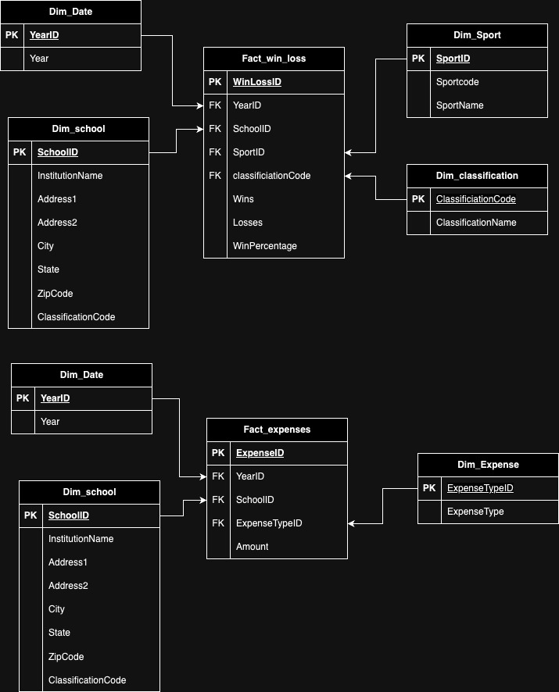

1. Either an actual flow, or a diagram of the ETL flow (you can use Whimsical) that you are going to implement to transform the current data into the star schema.

CSV -> Python -> LMU Build Database

CSV ->Tableau -> LMU Build Database

1. A sample of Python code/Tableau Prep/Alteryx flow that you are going to use in your project.

See python files uploaded to Brightspace

1. An updated timeline showing the plan for the project for the rest of the semester.

* 4/21: Finish uploading data to the data warehouse
* 4/22: Generate charts
* 4/23: Consolidate visuals into dashboards or stories
* 4/24: Presentation